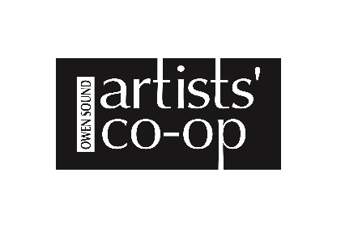Application Square Foot Show 12“ x 12“ July 7 to Aug 26, 2026
All sections must be completed to ensure there is no delay in the payment of your sales
Full Name: ___________________________________________________________________________
Business Name: ______________________________________________________________________
Complete mailing address including postal code:
______________________________________________________________________________________
Email: _______________________________________________________________________________
Telephone: ___________________________________________________________________________
Do you collect HST? Yes _______ No ________ Are you interested in becoming a member ___
Cheque to be payable to: ______________________________________________________________
Instructions for the return of your work:
_______________________________________________________________________________________
Intake of Artwork on Thursday July 2nd and Friday July 3rd.
Overall size of artwork is 12” x 12”. Minimum price of artwork $150.00 +
Fee of $20 +HST to be paid with application for up to 4 pieces and $40+ HST for
5 – 8 pieces. Commission of 35% on all sales.
No private sales. Artwork not to be removed from show unless sold through Artists’ Co-operative. Various mediums accepted.
Unsold Artwork to be picked up Thursday Aug 27
Please include the following with your submissions
: A completed application form
:Your artwork must be ready to hang and to display, your name and title on back
: label for art pieces, we have some at the front desk if you need them. Showing medium, title, price and your name
The Artists’ Co-op will handle your work with the utmost care, but we regret we cannot be responsible for any loss, theft or damage. Applicants are responsible for their own insurance. This form is the contract for your participation in our Legacy Gallery Program. Your signature releases the Artists’ Coop from liability.

I acknowledge I have read the second page of the application form. _______________
SIGNATURE: _________________________________________ DATE: _________________________

Please keep this information sheet on the Square Foot Show 12” x 12” for your records

1 A Fee of $20 + HST for up to 4 pieces and $40 + HST for 5 – 8 pieces at time of application will be charged.

2 A commission of 35% from all sales will be charged and deducted from your statement. The Artists’ Co-operative has a 30 day return policy, Cheques for the sale of work will be issued Sept 1st.

3 A completed application form to be submitted with your artwork or in advance by e-mail. Application forms are available at the Artists’ Co-operative or on our website.

4 All work must be intended for sale and MUST be labelled and ready to display . include the title of your piece, medium, price and your name in your label.

5 No private sale of artwork in Square Foot Show. Artwork not to be removed from show unless sold through Artists’ Co-operative. Participants can not offer similar artwork within a one block radius during the show.

6 Various mediums are welcome.

7 Overall size is 12” x 12”.

8 Work is to be dropped off

9 Email digital photos of your artwork and a short bio for our web site.

10 Artwork to be picked up Thursday August 27th.

11 We will advertise your event in our regular free event listings. All other advertising, including posters is your responsibility.

12 The Artists’ Co-operative will handle your work with the utmost care, but regret we can not
be responsible for any loss, theft or damage.

13 Applicants are responsible for their own insurance.

14 The Square Foot Show will run from July 7th to Aug 26th

